Week 6 | Groceries App: RESTful Services

This week’s improvements include:

1. Installed Mongo DB
2. Installed an updated version of Groceries-Service moving CRUD operations to a persistent data storage model (Mongo DB vs in-memory JSON)
3. Updated the Groceries App to use the new version of Groceries-Service for CRUD operations.

*See screenshots below showcasing my changes for the week.*

Weekly Questions:

1. GitHub Repository URL  
   <https://github.com/SWDV-665/week-6-groceries-app-restful-services-kerryfaine>
2. How many hours do you estimate you used completing this assignment?  
   I spent around 5 hours working on this assignment.
3. What was easiest for you when completing this assignment?  
   Testing the service locally and installing MongoDB was pretty straight forward.
4. What was the most difficult challenge you experienced when completing this assignment?  
   I had trouble with upgrading the Groceries Service. Was there code I was supposed to reference? I took the necessary edits from the videos but struggled a little with the update to the home.html screen since it was not shown in the video.

Screenshots

1. Installed MongoDB and created a groceries database. Using the provided curl commands, I added 2 items to the list.   
   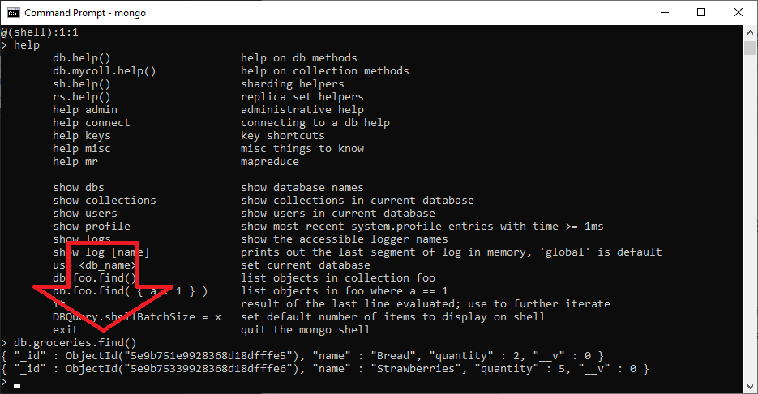
2. List of items in the MongoDB database using the upgraded Groceries-Service:   
   
3. Updated groceries app to use the newly upgraded CRUD operations
   1. Screen Load: The initial load matches the database results from #1 & 2 above.   
      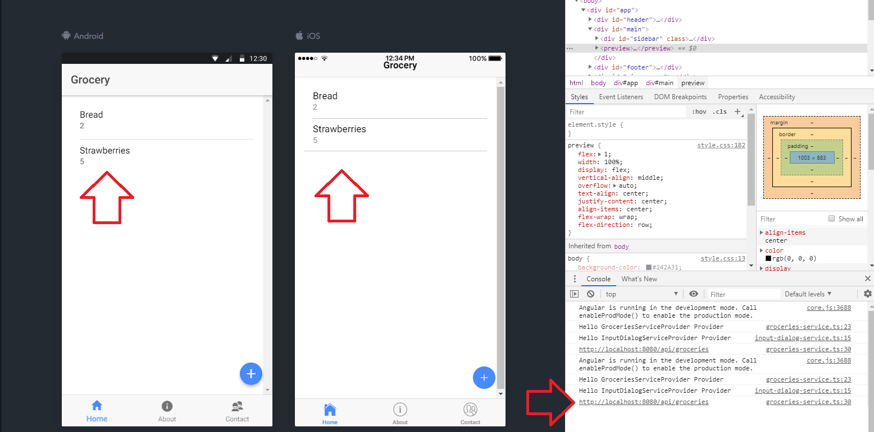
   2. Adding a new item  
      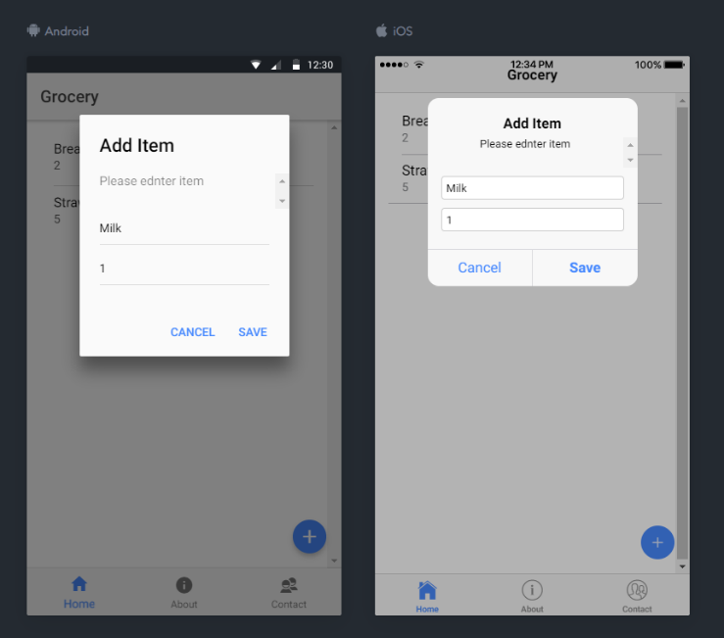  
        
      API call – resulting after ‘Save’ Clicked …   
      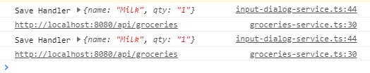

Database Query – after update …   
  
  
Screen after database save:   
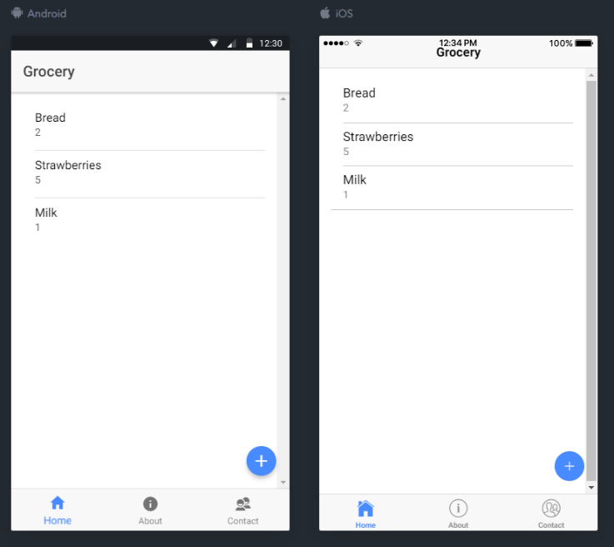

* 1. Deleting an item   
     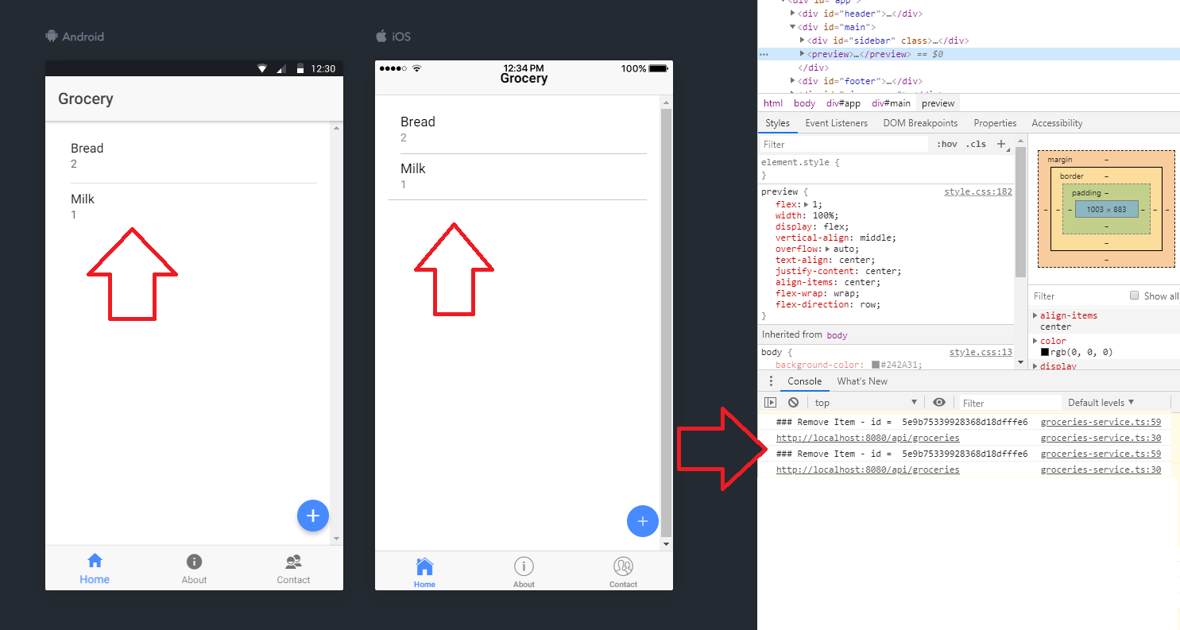  
       
     Database query results after deletion …   
     